LncRNA XIST Reduces Myocardial Injury in Myocarditis by Targeting the miR-140-3p/RIPK1 Axis

Jiaxin Zhou1

1**Jessica** ,University of California - San Diego

Email ID: [jiaxinbinganzhou@gmail.com](mailto:jiaxinbinganzhou@gmail.com)

00Cite this paper as: V. Duraisami, Prof. R. Mohana Krishnan, (2025) Effect of Integrated LncRNA XIST Reduces Myocardial Injury in Myocarditis by Targeting the miR-140-3p/RIPK1 Axis. *Journal of Neonatal Surgery*, 14 (5s), 531-538.

ABSTRACT

**Introduction:** Myocarditis, an inflammatory disease of the myocardium, can lead to serious cardiac conditions such as arrhythmias, systolic and diastolic dysfunction, and, in severe cases, sudden cardiac death. The condition has various etiologies, including immune response, bacterial, and viral infections, but its pathophysiology is not yet fully understood, and treatment remains largely symptomatic. Long non-coding RNAs (lncRNAs), particularly X inactivation-specific transcript (XIST), have emerged as significant regulators in cardiac diseases. However, XIST's role in myocarditis has not been fully elucidated. This study investigates XIST's protective effects on primary rat cardiomyocytes during lipopolysaccharide-induced myocarditis and explores its underlying molecular mechanism.

**Materials and Methods:** Rat primary cardiomyocytes were treated with XIST-loaded lentiviruses and exposed to lipopolysaccharide (LPS) to induce myocarditis. Quantitative PCR was used to determine XIST expression, while MTS, ELISA, flow cytometry, and Western blot assays evaluated cell viability, cytokine levels, apoptosis, and protein expression. Bioinformatics analysis and a dual-luciferase reporter assay examined the interaction between XIST and miR-140-3p.

**Results:** Compared with the control group, XIST overexpression in cardiomyocytes significantly increased cell viability, reduced IL-1β and TNF-α secretion, and decreased apoptosis. Bioinformatics and dual-luciferase reporter assay confirmed miR-140-3p as a direct target of XIST, suggesting XIST regulates cardiomyocyte survival through miR-140-3p interaction.

**Conclusion:** XIST exerts a protective role against LPS-induced cardiomyocyte injury in myocarditis, potentially by targeting miR-140-3p. These findings provide new insights into lncRNA-based therapeutic strategies for myocarditis.

***Keywords:*** *myocarditis, XIST, miR-140-3p, RIPK1, apoptosis*

1. INTRODUCTION

Myocarditis refers to an inflammatory disease in which the myocardium is involved and leads to cardiomyocyte lesions, which is caused by a variety of etiologies such as immune damage, bacterial infection, and viral infection (1). Myocarditis can cause cardiac arrhythmias leading to systolic and diastolic dysfunction (2). The clinical manifestations of myocarditis are chest tightness, palpitations, arrhythmia and even heart failure. In severe cases, it can lead to sudden cardiac death (3). The pathological process of myocarditis is not completely clear, and the clinical treatment is mainly symptomatic treatment (4). Long non-coding RNA (lncRNA) is a class of endogenous non-coding RNAs greater than 200 nucleotides, which are widely present in the cytoplasm or nucleus (5). lncRNAs regulate gene expression in an epigenetic manner at the transcriptional and post-transcriptional levels, and affect cell differentiation, proliferation, apoptosis and other functions (6). Some studies (7, 8) showed that the abnormal expression of lncRNA is related to the occurrence and development of various cardiac diseases. In recent years, long noncoding X inactivation-specific transcript (XIST) RNA has become a hot spot in lncRNA research, and its role in promoting cancer genes in colorectal cancer and liver cancer has been highlighted. The function and mechanism of lncRNA XIST in cardiac diseases, especially myocarditis, are still unclear. The purpose of this study was to observe the protective effect of lncRNA XIST on primary rat cardiomyocytes during lipopolysaccharide-induced myocarditis and the possible molecular mechanism.

1. Materials and Methods

Cell Culture

Rat heart tissues were digested with Collagenase I (Beyotime Biotechnology, Shanghai, China) to isolate single-cell suspensions, which were subsequently cultured in DMEM medium (HyClone, Logan, UT) supplemented with 20% fetal bovine serum, maintained at 37°C in a 5% CO₂ environment. After 24 hours, a fluorescence microscope captured images of lentiviruses carrying XIST sequences and control lentiviruses (Sangon Biotech, Shanghai, China), forming the XIST and Control groups. Each group then received a 100 μL application of lipopolysaccharide at a 10 μmol/L concentration (Invitrogen, CA, USA) and was incubated for an additional 24 hours.

Quantitative Real-Time PCR (qRT-PCR)

TRIzol (Invitrogen, USA) was used to extract total RNA from each cell group, which was subsequently converted to complementary DNA (cDNA) using an RT-PCR kit (Promega, USA). Quantification of the target genes was performed using a qRT-PCR kit (QIAGEN, Germany), with β-actin as a reference for comparing relative RIPK1 and XIST mRNA levels and U6 for analyzing miR-140-3p expression. Primer sequences included: U6 forward (CGCGCTTCGGCAGCACATATACT) and reverse (ACGCTTCACGAATTTGCGTGTC); miR-140-3p forward (ACACGGTGTAACATCCTCAGAC) and reverse (CAGTGGAGTGTGCGTCT); β-actin reverse (CAATCAGAGCAGG); XIST forward (TGGTGTTATGATGTGATAC); and RIPK1 forward (GTCGCTCCTAGACACTGA). The reaction included a pre-denaturation phase at 95°C for 6 minutes, followed by denaturation at 95°C for 30 seconds, and annealing at 60°C for 25 seconds.

MTS Assay

In 96-well plates, 2×10³ primary rat cardiomyocytes, previously treated with lipopolysaccharide, were seeded. After 24 hours, 20 μL of MTS solution (Beyotime, Shanghai, China) was added per well and incubated in the dark for 3 hours. Absorbance at 450 nm was measured using a microplate reader to assess cellular health within each group.

Enzyme-Linked Immunosorbent Assay (ELISA)

Post-lipopolysaccharide treatment, cell supernatants were collected, and IL-1β and TNF-α levels were measured using an ELISA kit (Abcam, USA) following the manufacturer’s guidelines. Absorbance readings at 450 nm were obtained via a microplate reader, enabling the comparison of IL-1β and TNF-α concentrations across groups.

**Flow Cytometry Assay**

Following lipopolysaccharide treatment, primary rat cardiomyocytes were digested, centrifuged, and resuspended in buffer. For each group, 100 μL of cell suspension was mixed with 5 μL of Annexin V-FITC and 5 μL of PI solution (YEASEN, China) before incubation for 20 minutes at 4°C. Samples were diluted with 100 μL of buffer prior to analysis using a FACSCalibur flow cytometer (Becton Dickinson, USA), where apoptotic ratios were quantified.

Bioinformatics and Dual-Luciferase Reporter Assays

Potential binding sites between XIST and miR-140-3p were identified using StarBase V3.0 (http://starbase.sysu.edu.cn/index.php). In 293T cells, miR-140-3p or miR-NC was co-transfected with XIST-WT or XIST-MT fluorescent reporter vectors (Sangon Biotech, China). Forty-eight hours post-transfection, a dual-luciferase reporter assay (TransGene, China) measured luciferase activity; relative luciferase activity was calculated by dividing firefly luciferase activity by sea cucumber luciferase activity.

Western Blot

Primary cardiomyocytes from each group were digested with trypsin, lysed using a cell lysate (Beyotime, China), and total protein was extracted by centrifugation. Protein samples, combined with loading buffer, were separated by SDS-PAGE (Sigma, USA) at 100°C for 8 minutes and transferred onto a nitrocellulose membrane. Following a 3-hour blocking period with 5% nonfat milk, membranes were incubated overnight at 4°C with primary antibodies, then with secondary antibodies for 3 hours. Protein bands were visualized using a gel imaging system after the addition of an electrogenerated chemiluminescence reagent.

Data Analysis

Experimental data were analyzed using SPSS 20.0 statistical software, with measurement data expressed as mean ± standard deviation (x±s). Differences between groups were evaluated with a t-test, with P<0.05 indicating statistical significance.

1. Results

Relative Expression Levels of XIST in Primary Cardiomyocytes

Fluorescence microscopy revealed green fluorescence in the primary cardiomyocytes from both the XIST and Control groups, verifying successful lentiviral infection. qRT-PCR results indicated that XIST expression in the XIST group was elevated compared to the Control group.

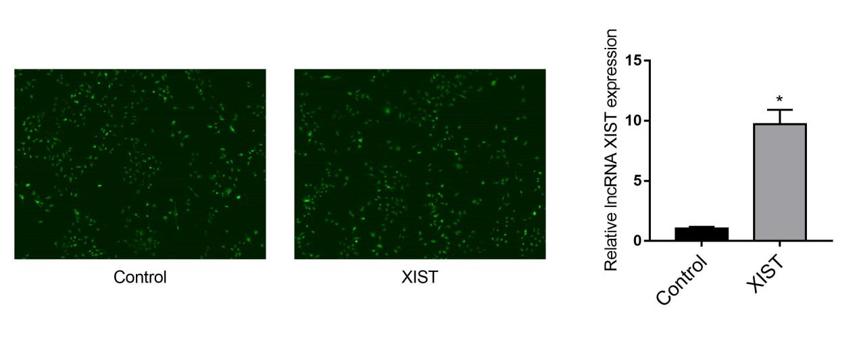

Fig.1 Relative expression levels of XIST in primary cardiomyocytes Compared with Control, \**P*＜0.05

**The impact of elevated XIST expression on primary rat cardiomyocyte viabilit**

Following LPS treatment, MTS assessed the viability of primary cardiomyocytes in both the control and XIST groups. The findings demonstrated that the XIST group's primary cardiomyocyte viability was higher than that of the control group.

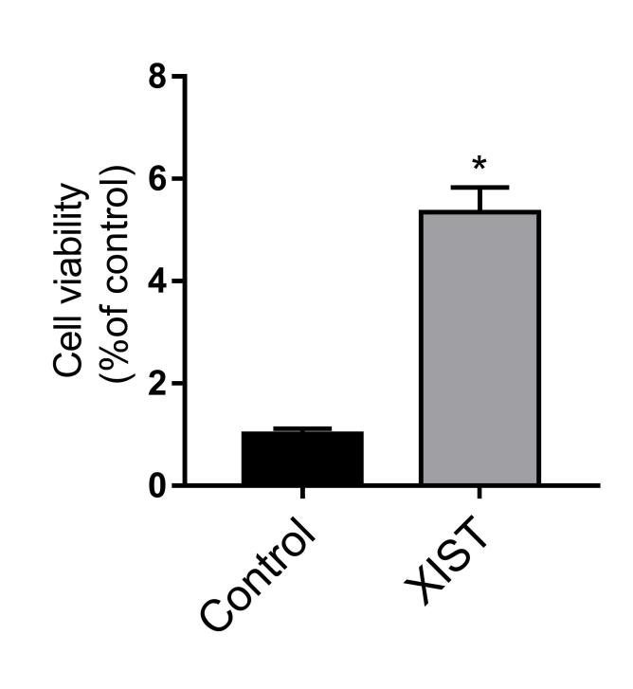

Fig.2 The viability of primary cardiomyocytes Compared with Control, \**P*＜0.05

**The impact of elevated XIST expression on the amount of TNF-α and IL-1β in the supernatant**

According to ELISA data, following lipopolysaccharide treatment, the levels of IL-1β in the supernatants of the control and XIST groups were, respectively, 25.13±2.03 pg/mL and 10.28±1.68 pg/mL. The XIST group's supernatants had TNF-α levels of 14.26±1.95 pg/mL and the Control group's were 32.26±3.71 pg/mL. In conclusion, the XIST group's supernatant had lower amounts of TNF-α and IL-1β than the Control group.

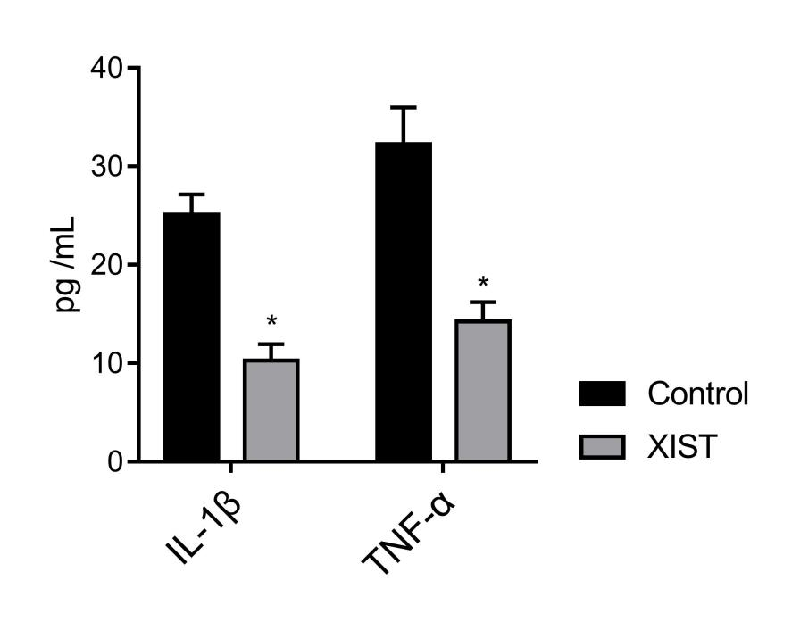

Fig.3 The content of IL-1β and TNF-α in the supernatant Compared with Control, \**P*＜0.05

**Impact of elevated XIST expression on primary rat cardiomyocyte apoptosis**

The apoptosis ratios of primary cardiomyocytes in the XIST group and Control group were 12.61±2.05% and 29.25±2.46%, respectively, following a 24-hour lipopolysaccharide treatment, according to flow cytometry. This suggests that the high expression of XIST inhibited the apoptosis of primary rat cardiomyocytes when compared to the Control group.

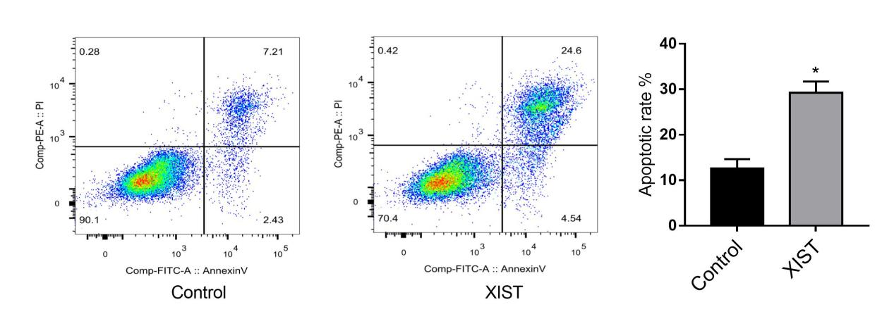

Fig.4 Apoptosis of primary rat cardiomyocytes Compared with Control, \**P*＜0.05

**MiR-140-3p is XIST's target.**

According to bioinformatics software (starBase V3.0), XIST might be able to target miR-140-3p. According to the dual luciferase reporter gene assay results, there were substantial differences between the XIST-WT/miR-NC, XIST-WT/miR-140-3p, XIST-MT/miR-NC, and XIST-MT/miR-140-3p groups. The relative luciferase activity of the XIST-WT/miR-140-3p group was lower than that of the XIST-WT/miR-NC group, as indicated by the luciferase activities of 1.03±0.12, 0.33±0.05, 0.96±0.04, and 0.99±0.10, respectively. The findings above imply that miR-140-3p can be targeted and bound by XIST.

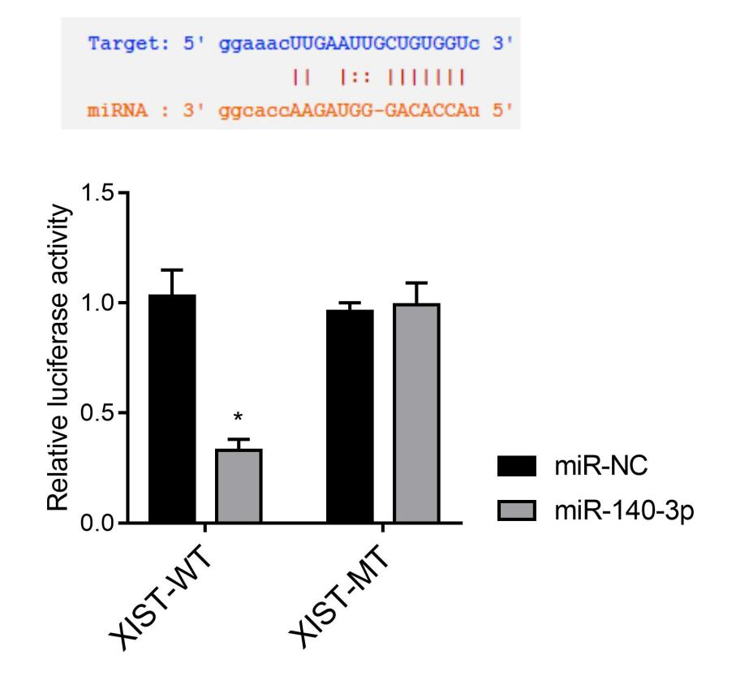

Fig.5 XIST can target and bind miR-140-3p Compared with miR-NC, \**P*＜0.05

**Impact of elevated XIST expression on the expression of RIPK1 mRNA and miR-140-3p in primary rat cardiomyocytes**

The primary cardiomyocytes of the XIST group and the control group had miR-140-3p expression levels of 0.29±0.05 and 1.02±0.12, respectively, according to the qRT-PCR data, suggesting that high XIST expression suppressed miR-140-3p expression. Primary cardiomyocytes in the XIST group and control group expressed RIPK1 mRNA at 5.82±0.79 and 1.05±0.08, respectively. This suggests that RIPK1 mRNA expression can be promoted by high XIST expression.

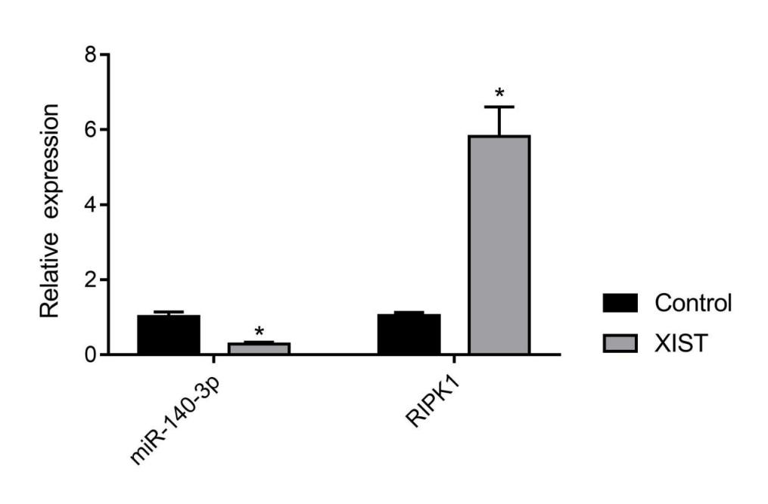

Fig.6 miR-140-3p and RIPK1 mRNA expression in primary rat cardiomyocytes Compared with Control, \**P*＜0.05

**Impact of elevated XIST expression on RIPK1 and apoptosis-related protein expression**

As demonstrated by the Western blot data, the primary cardiomyocytes of the XIST group exhibited increased RIPK1 protein expression, increased anti-apoptotic protein Bcl-2 expression, and decreased pro-apoptotic protein Bax and Caspase-3 expression as compared to the control group.

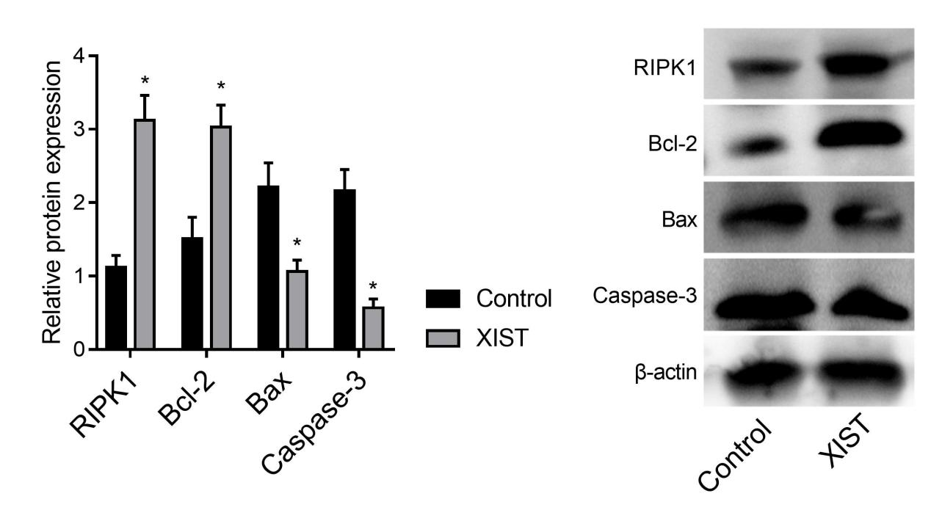

Fig.7 The expression of RIPK1 protein and apoptosis-related proteins Compared with Control, \**P*＜0.05

1. Discussion

Myocarditis can induce a series of pathological changes, such as inflammatory exudation, increased myocardial oxygen consumption, myocardial cell apoptosis, and decreased myocardial cell viability (9). The pathogenesis of myocarditis is complex, and the main diagnostic methods for myocarditis are currently histopathology and immunohistochemistry (10). Finding new molecular targets has important clinical significance for myocarditis diagnosis, treatment, and prognosis.

LncRNAs play a major role in controlling the onset and progression of certain cardiovascular disorders. According to Cao et al. (11) myocarditis caused by Coxsackie virus B3 was associated with elevated expression of lncRNA HIF1A-AS1, and by targeting miR-138, down-regulating lncRNA HIF1A-AS1 expression can effectively reduce cardiomyocyte death. According to Zhang et al. (12), lncRNA ROR altered the expression of the C-Myc protein, which in turn induced cardiac fibrosis in rats with viral myocarditis. According to certain research (13, 14), XIST is an oncogene in thyroid and gastric cancer, can accelerate the growth and spread of tumors, and is strongly correlated with the prognosis of tumor patients. Uncertainty surrounds the function and molecular mechanism of XIST on cardiomyocytes in myocarditis. This study showed that after lipopolysaccharide treatment, overexpression of XIST could inhibit the exudation of inflammatory factors IL-1β and TNF-α and reduce the inflammatory response. At the same time, XIST can enhance the viability of rat primary cardiomyocytes, inhibiting apoptosis and reducing the damage to cardiomyocytes. The primary way that lncRNAs work is the "sponge effect," that is, the complementary binding of miRNAs, reducing the interference effect of miRNAs on their downstream target genes, thereby up-regulating the expression of miRNA downstream target genes (15). The result predicted by starBase V 3.0 showed that the XIST may complementarily bind to miR-140-3p, which also further examined by the dual-luciferase reporter assay. Studies have shown that serum miRNA levels are increased in patients with acute viral myocarditis, which may promote myocardial inflammation by targeting RIPK1. The occurrence of this reaction causes irreversible damage to cardiomyocytes (16).

The RIPK1 gene is located on chromosome 6p25.2, and the RIPK1 protein plays a negative feedback regulatory role in the cytokine signaling pathway, which can inhibit the progression of myocarditis (17). For example, the mouse model of acute viral myocarditis induced by coxsackie virus B3 overexpresses RIPK1/RIPK3, and the inhibition of necroptosis pathway by Nec-1 can alleviate acute viral myocarditis (18). This study showed that the expression of miR-140-3p was decreased with the expression of RIPK1 mRNA being increased in primary rat cardiomyocytes after XIST upregulation, indicating that XIST upregulated the expression of RIPK1 mRNA by targeting miR-140-3p. Western blot analysis further showed that after the high expression of XIST, the protein expressions of RIPK1 and Bcl-2 were upregulated as well as protein expressions of Bax and Caspase-3 were down-regulated, indicating that XIST can inhibit the apoptosis of primary rat cardiomyocytes.

1. Conclusion

In this study, we successfully isolated and cultured primary rat cardiomyocytes to explore the functional role of XIST in a lipopolysaccharide (LPS)-induced inflammatory model. By employing lentiviral-mediated XIST overexpression, we observed a significant increase in XIST expression in cardiomyocytes, as verified through fluorescence microscopy and qRT-PCR analyses. Our quantitative assessments demonstrated that XIST upregulation was associated with notable changes in the expression of inflammatory markers, including IL-1β and TNF-α, as measured through ELISA. The MTS assay indicated that LPS exposure reduced cardiomyocyte viability, while XIST overexpression partially mitigated this effect.

Moreover, bioinformatic analysis and dual-luciferase reporter assays identified miR-140-3p as a potential target of XIST, suggesting that XIST might exert its protective effect by modulating miR-140-3p expression. Western blot results further supported this mechanism by showing altered protein expression in XIST-overexpressed cells compared to controls. Flow cytometry revealed that XIST overexpression also reduced apoptosis rates in LPS-treated cardiomyocytes, highlighting a potential anti-apoptotic and anti-inflammatory role for XIST in this context.

In summary, this study sheds light on the protective role of XIST in LPS-induced inflammatory responses in cardiomyocytes, potentially mediated via the regulation of miR-140-3p and downstream inflammatory pathways. These findings suggest that XIST could serve as a therapeutic target in mitigating cardiomyocyte inflammation and apoptosis, offering insights into possible therapeutic strategies for inflammatory heart diseases.

Author contributions: Study conception and design, JK; data collection,

NSW; analysis and interpretation of results, NSW and JK; draft manuscript

preparation, NSW and JK. All authors have read and agreed to the published

version of the manuscript.

Data availability statement: The survival data analyzed in this study was

obtained from the KM plotter database

https://kmplot.com/analysis/index.php?p=service&cancer=colon) and the data

for ROC analysis was obtained from ROC plotter

(https://www.rocplot.com/colorectal).

Conflict of interest: The authors declare no conflict of interest

REFERENCES

* 1. Daba TM, Zhao Y, Pan Z. Advancement of Mechanisms of Coxsackie Virus B3-Induced Myocarditis Pathogenesis and the Potential Therapeutic Targets. Curr Drug Targets. 2019;20(14):1461-73.
  2. Zhu K, Miao C, Tian Y, Qin Z, Xue J, Xia J, et al. lncRNA MIR4435-2HG promoted clear cell renal cell carcinoma malignant progression via miR-513a-5p/KLF6 axis. J Cell Mol Med. 2020;24(17):10013-26.
  3. Bonaca MP, Olenchock BA, Salem JE, Wiviott SD, Ederhy S, Cohen A, et al. Myocarditis in the Setting of Cancer Therapeutics: Proposed Case Definitions for Emerging Clinical Syndromes in Cardio-Oncology. Circulation. 2019;140(2):80-91.
  4. Jain S, Nolan SM, Singh AR, Lovig L, Biller R, Kamat A, et al. Myocarditis in Multisystem Inflammatory Syndrome in Children Associated With Coronavirus Disease 2019. Cardiol Rev. 2020;28(6):308-11. XIAO, Ting; LI, Qiong. The Evaluation of Classroom Teaching Quality of College Business English Translation Based on AI and Central Tendency Adaptive Enhancement. Journal of Combinatorial Mathematics and Combinatorial Computing, 119: 53-62.
  5. Azizi Z, Mirtavoos-Mahyari H, Karimi R, Noroozi Z, Motevaseli E. Long non-coding RNAs: Diverse roles in various disorders. Hum Antibodies. 2019;27(4):221-5.
  6. Angrand PO, Vennin C, Le Bourhis X, Adriaenssens E. The role of long non-coding RNAs in genome formatting and expression. Front Genet. 2015;6:165.
  7. Yang X, Zhang S, He C, Xue P, Zhang L, He Z, et al. METTL14 suppresses proliferation and metastasis of colorectal cancer by down-regulating oncogenic long non-coding RNA XIST. Mol Cancer. 2020;19(1):46.
  8. Liu L, Jiang H, Pan H, Zhu X. LncRNA XIST promotes liver cancer progression by acting as a molecular sponge of miR-200b-3p to regulate ZEB1/2 expression. J Int Med Res. 2021;49(5):3000605211016211.
  9. Tschope C, Cooper LT, Torre-Amione G, Van Linthout S. Management of Myocarditis-Related Cardiomyopathy in Adults. Circ Res. 2019;124(11):1568-83. Lv, T. (2024). Analysis of Home Product Design Method for the Elderly Based on Behavioral Adaptive Evaluation. International Journal for Housing Science and Its Applications, 45(1), 25-31.nHE, Lin; NIU, Jie. Identification of Traditional Culture Communication in Social Media Based on Information Dissemination Tree. Journal of Combinatorial Mathematics and Combinatorial Computing, 2024, 120.1: 219-229.
  10. Saqib, K. (2024). Postmodernism, Social Dynamics, and E-Commerce Evolution. International Journal for Housing Science and Its Applications, 45(1), 20-24.
  11. Guo, L., & Sun, Y. (2024). Economic Forecasting Analysis of High-Dimensional Multifractal Action Based on Financial Time Series. International Journal for Housing Science and Its Applications, 45(1), 11-19.
  12. Altay, A., & Mirici, İ. H. (2024).Efl Instructors’ Implementations of 21st Century Skills in Their Classes. International Journal for Housing Science and Its Applications, 45(2), 37-46.
  13. Wu, Y. (2024). Exploration of the Integration and Application of the Modern New Chinese Style Interior Design. International Journal for Housing Science and Its Applications, 45(2), 28-36.
  14. Chen, P. (2024). Research on Business English Approaches from the Perspective of Cross-Cultural Communication Competence. International Journal for Housing Science and Its Applications, 45(2), 13-22.
  15. Wang, W. (2024). Esg Performance on the Financing Cost of A-Share Listed Companies and an Empirical Study. International Journal for Housing Science and Its Applications, 45(2), 1-7.
  16. Fei Y, Chaulagain A, Wang T, Chen Y, Liu J, Yi M, et al. MiR-146a down-regulates inflammatory response by targeting TLR3 and TRAF6 in Coxsackievirus B infection. RNA. 2020;26(1):91-100.
  17. Cao H, Yang B, Zhao Y, Deng X, Shen X. The pro-apoptosis and pro-inflammation role of LncRNA HIF1A-AS1 in Coxsackievirus B3-induced myocarditis via targeting miR-138. Cardiovasc Diagn Ther. 2020;10(5):1245-55.
  18. Zhang N, Sun Y. LncRNA ROR facilitates myocardial fibrosis in rats with viral myocarditis through regulating C-Myc expression. Eur Rev Med Pharmacol Sci. 2019;23(24):10982-8.
  19. Du YL, Liang Y, Cao Y, Liu L, Li J, Shi GQ. LncRNA XIST Promotes Migration and Invasion of Papillary Thyroid Cancer Cell by Modulating MiR-101-3p/CLDN1 Axis. Biochem Genet. 2021;59(2):437-52. Guo, L., & Sun, Y. (2024). Economic Forecasting Analysis of High-Dimensional Multifractal Action Based on Financial Time Series. International Journal for Housing Science and Its Applications, 45(1), 11-19.
  20. Altay, A., & Mirici, İ. H. (2024).Efl Instructors’ Implementations of 21st Century Skills in Their Classes. International Journal for Housing Science and Its Applications, 45(2), 37-46.
  21. Wu, Y. (2024). Exploration of the Integration and Application of the Modern New Chinese Style Interior Design. International Journal for Housing Science and Its Applications, 45(2), 28-36.
  22. Chen, P. (2024). Research on Business English Approaches from the Perspective of Cross-Cultural Communication Competence. International Journal for Housing Science and Its Applications, 45(2), 13-22.
  23. Zheng W, Li J, Zhou X, Cui L, Wang Y. The lncRNA XIST promotes proliferation, migration and invasion of gastric cancer cells by targeting miR-337. Arab J Gastroenterol. 2020;21(3):199-206.
  24. Dhawan A. Mathematical Modeling of ceRNA-Based Interactions. Methods Mol Biol. 2021;2324:105-14.
  25. Elton TS, Selemon H, Elton SM, Parinandi NL. Regulation of the MIR155 host gene in physiological and pathological processes. Gene. 2013;532(1):1-12.
  26. Leng Y, Zhang Y, Li X, Wang Z, Zhuang Q, Lu Y. Receptor Interacting Protein Kinases 1/3: The Potential Therapeutic Target for Cardiovascular Inflammatory Diseases. Front Pharmacol. 2021;12:762334. XIAO, Ting; LI, Qiong. The Evaluation of Classroom Teaching Quality of College Business English Translation Based on AI and Central Tendency Adaptive Enhancement. Journal of Combinatorial Mathematics and Combinatorial Computing, 119: 53-62.
  27. Zhou F, Jiang X, Teng L, Yang J, Ding J, He C. Necroptosis may be a novel mechanism for cardiomyocyte death in acute myocarditis. Mol Cell Biochem. 2018;442(1-2):11-8.